**PROJECT REPORT**

**(HEALTH HUB MEDICAL CLINIC)**

**1 INTRODUCTION**

1.1 Overview A brief description about your project

1.2 Purpose The use of this project. What can be achieved using this

**2 PROBLEM DEFINITION&DESIGN THINKING**

**2.1 Empathy Map Paste the empathy map screenshot**

**2.2 Ideation & Brainstorming Map Paste the Ideation & brainstorming map screenshot**

**3 RESULT**

**Final findings (Output) of the project along with screenshots.**

**4 ADVANTAGES & DISADVANTAGES**

List of advantages and disadvantages of the proposed solution

**5 APPLICATIONS**

The areas where this solution can be applied

**6 CONCLUSION**

**Conclusion summarizing the entire work and findings**

**7 FUTURE SCOPE**

**Enhancements that can be made in the future.**

**8APPENDIX**

1. **Source Code Attach the code for the solution built**

**1.INTRODUCTION**

1.1 Overview A brief description about your project

A **medical clinic is a type of facility that’s focused on outpatient services. Being an outpatient means that you can go home after you receive care. Medical clinics can be operated publicly, privately, or by the government. You often need to make an appointment to go to a medical clinic, although some clinics may also accept walk-ins**

A **clinic** (or **outpatient clinic** or **ambulatory care clinic**) is a health facility  that is primarily focused on the care of outpatients. Clinics can be privately operated or publicly managed and funded. They typically cover the primary care needs of populations in local communities, in contrast to larger hospitals which offer more specialized treatments and admit inpatients for overnight stays.

Most commonly, the English word clinic refers to a general practice run by one or more general pracititioner offering small therapeutic treatments, but it can also mean a specialist clinic. Some clinics retain the name "clinic" even while growing into institutions as large as major hospitals or becoming associated with a hospital or medical school.

Purpose The use of this project. What can be achieved using this

**Strong project management helps improve healthcare and the healthcare industry in a number of ways. Project management can do the following: Improve the quality of care by improving processes used to provide that care. Improve communication among healthcare staff caring for patients. improve organizational planning.**

**2 PROBLEM DEFINITION&DESIGN THINKING**

**2.1 Empathy Map Paste the empathy map screenshot**

**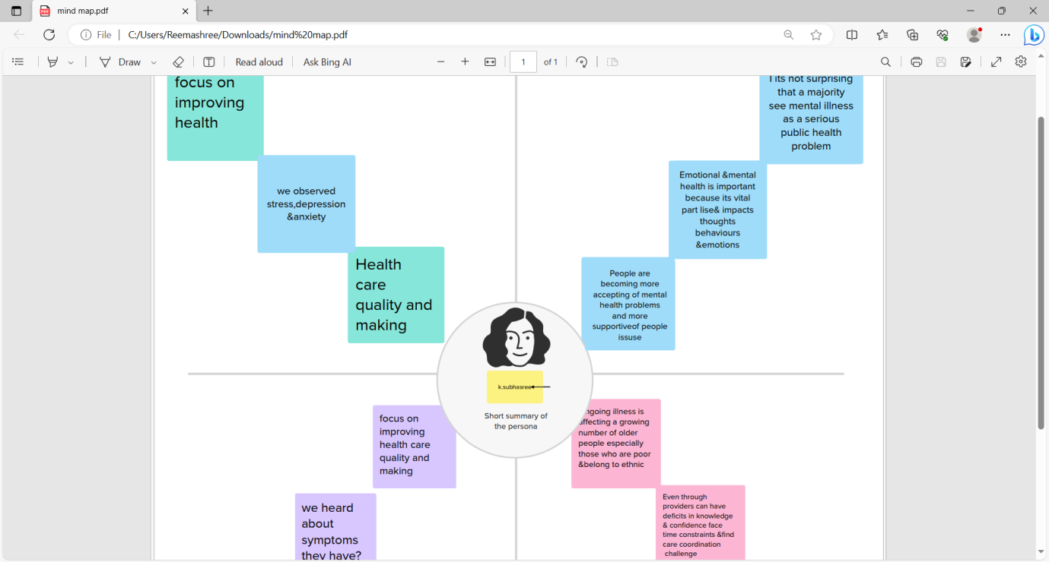**

**2.2 Ideation & Brainstorming Map Paste the Ideation & brainstorming map screenshot**

**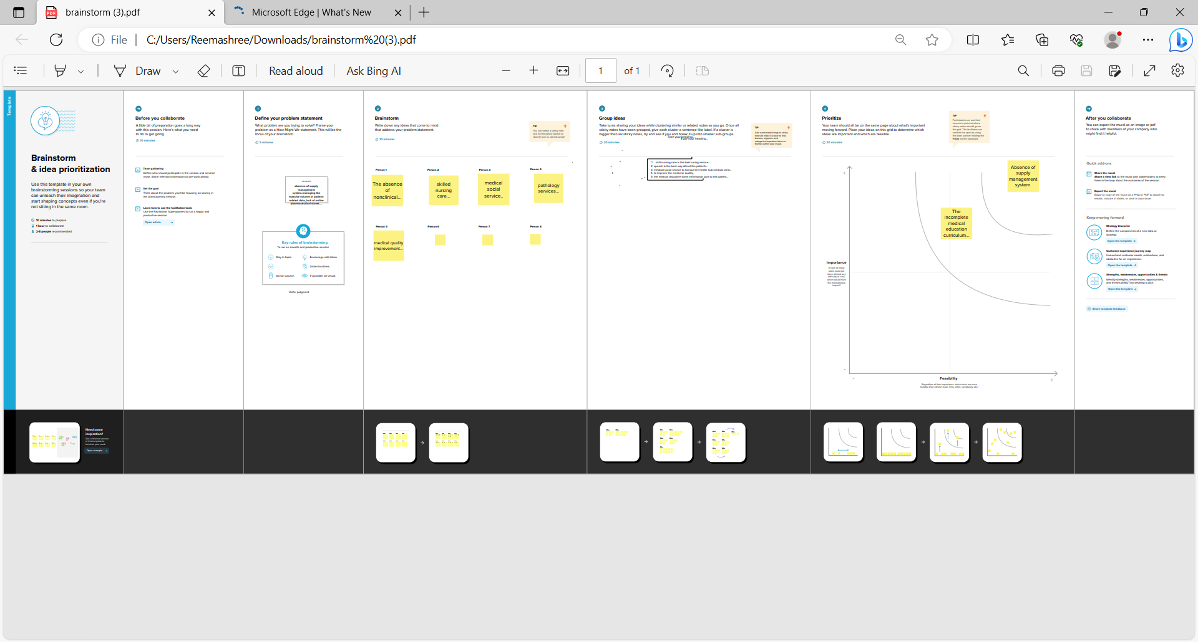**

**3 RESULT**

**Final findings (Output) of the project along with screenshots.**

**1.GST Reports**

**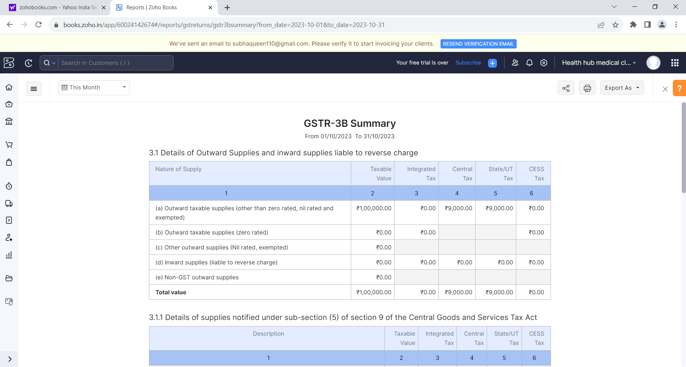**

**2.againg receivable summary**

**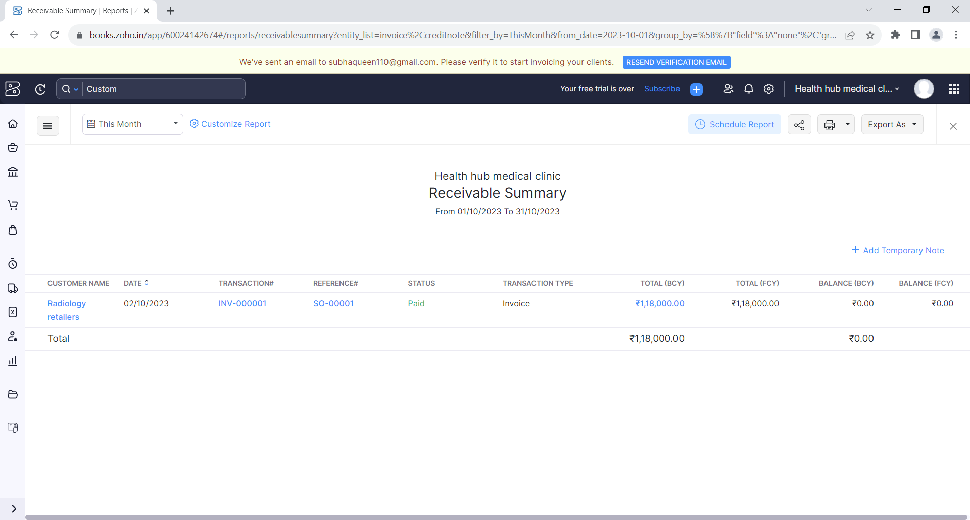**

**3.Againg payable summary**

**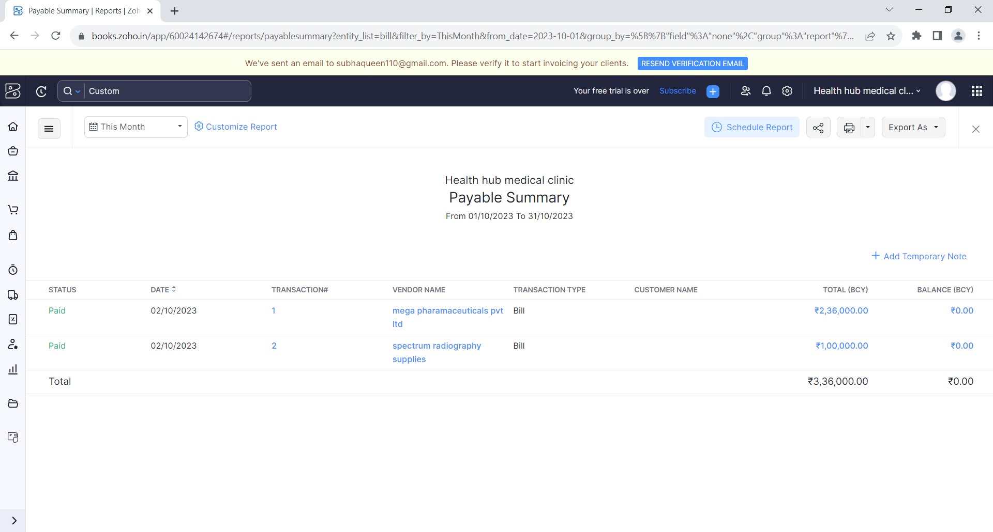**

**4.items**

**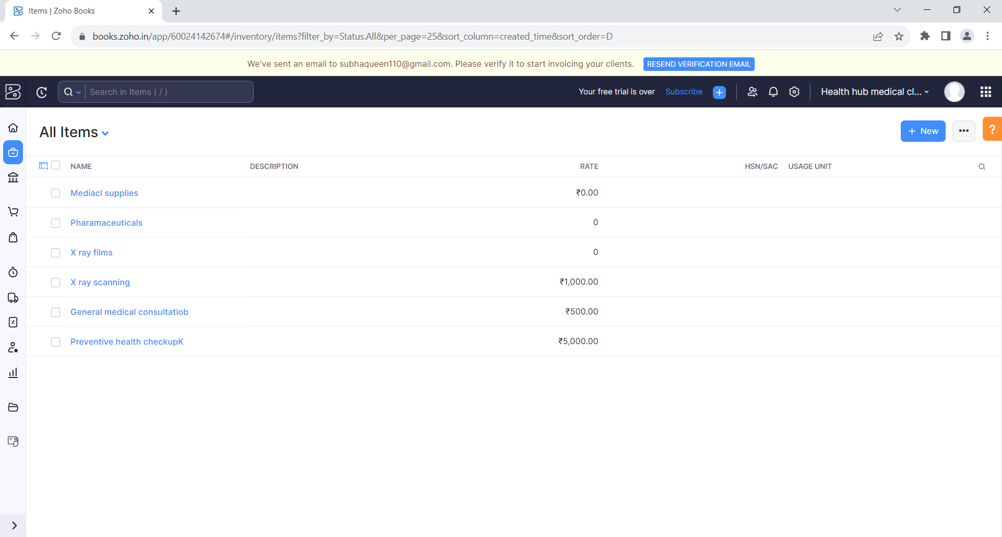**

**5.sales invoice**

**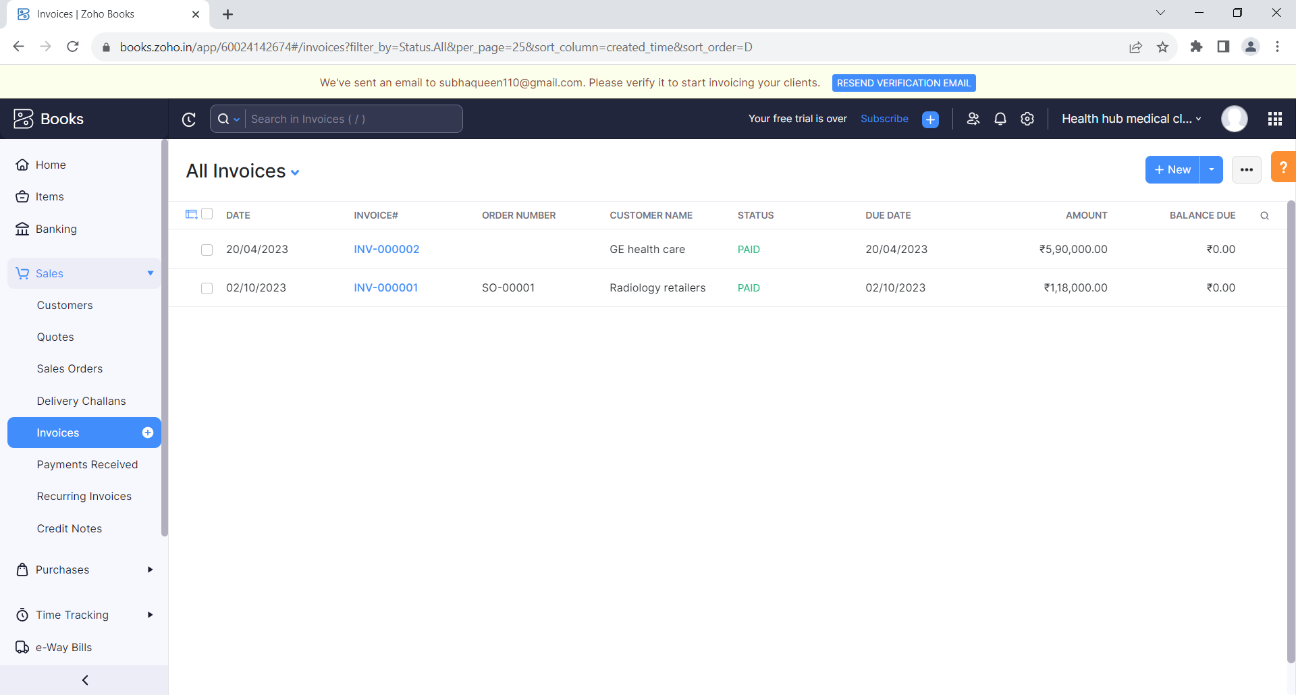**

**6.purchase bills**

**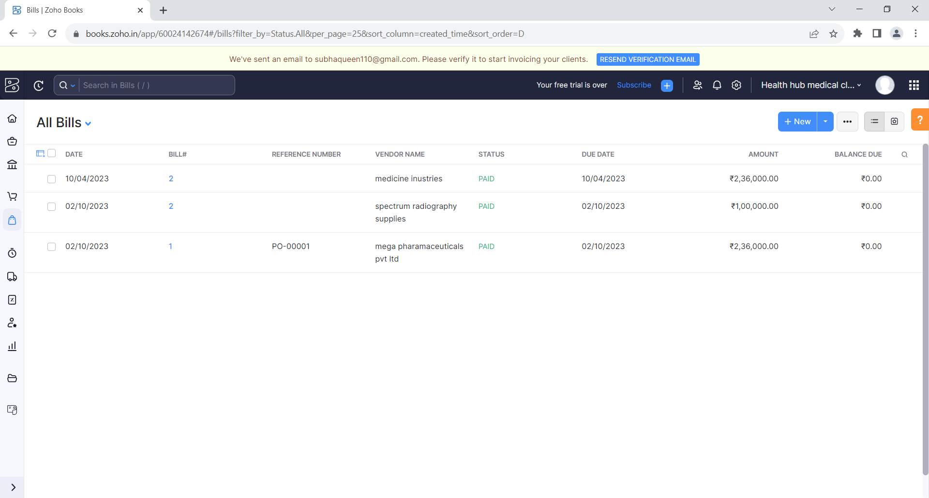**

**7.customer**

**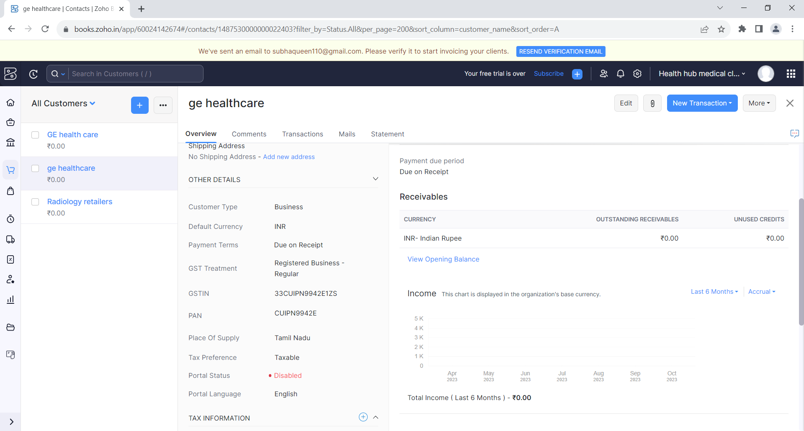**

**8.vendors**

**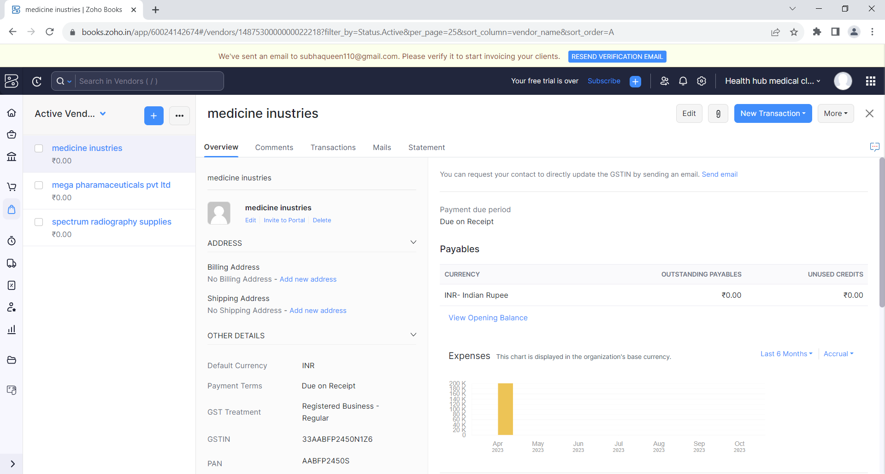**

**9.banking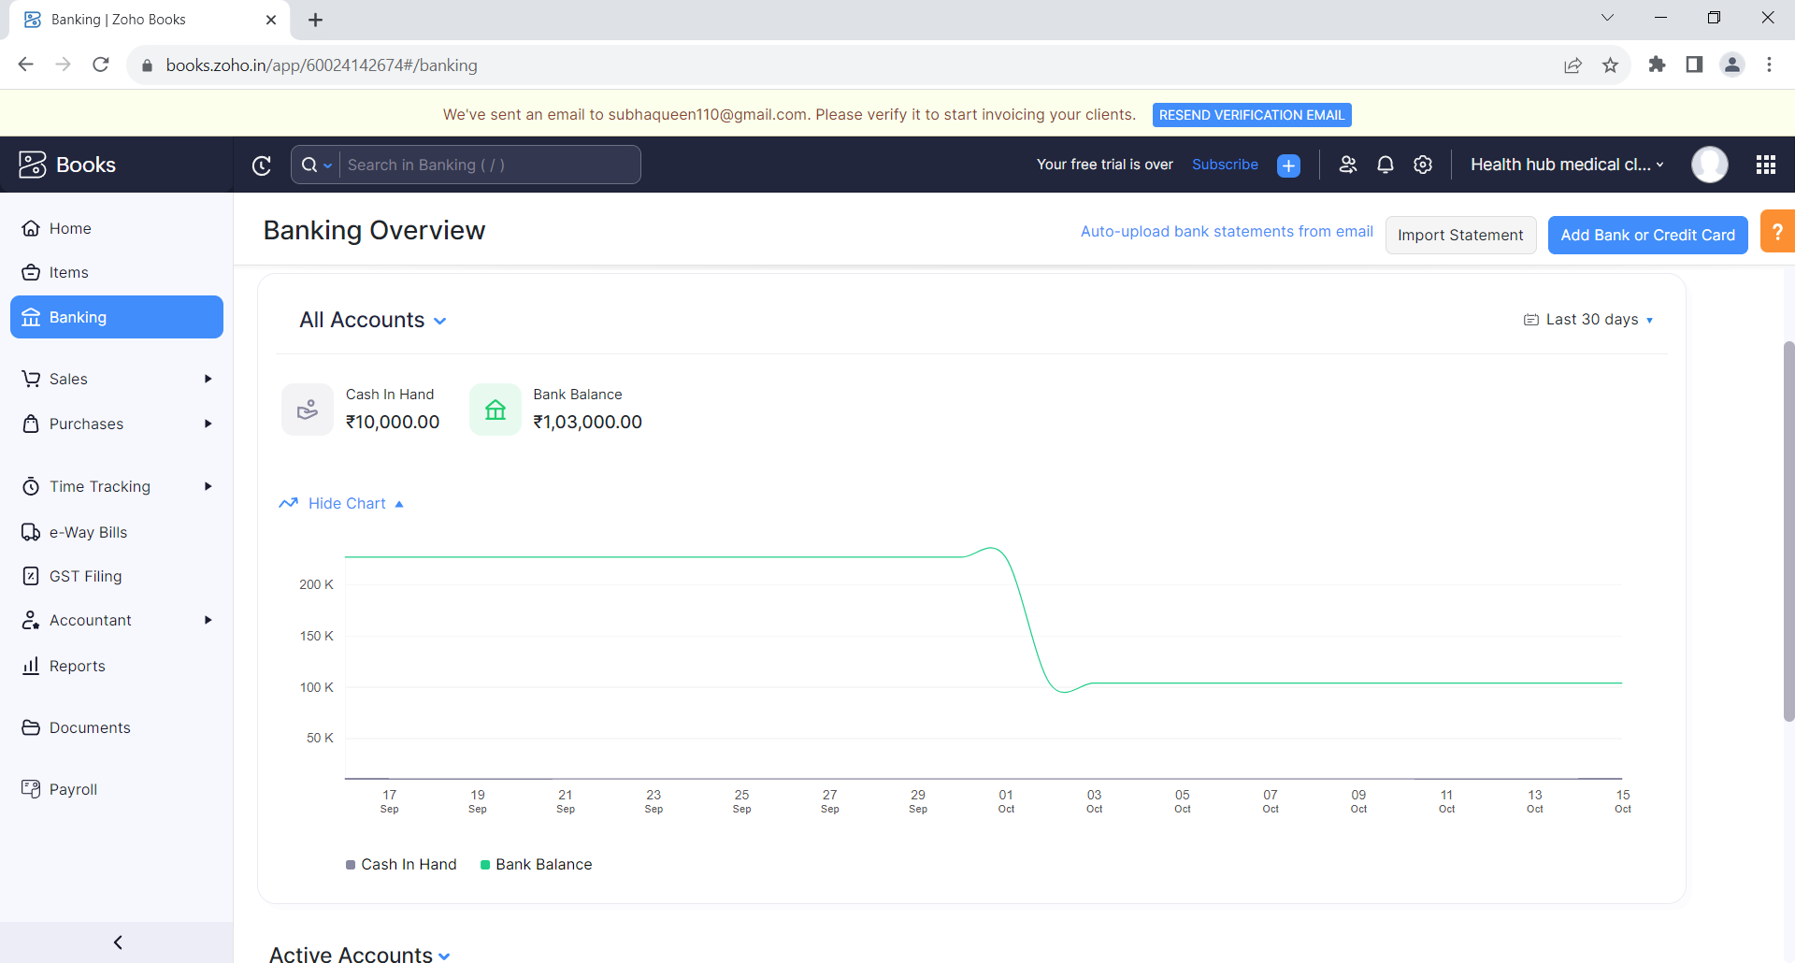**

**4 ADVANTAGES & DISADVANTAGES**

List of advantages and disadvantages of the proposed solution

ADVANTAGES

A Medical Clinic is a primary healthcare facility which provides medical assistance to anyone who needs it. Medical clinics were originally made for people who didn’t have insurance as their services are comparatively less expensive than conventional Emergency rooms. But today Medical clinics have become an ingrained part of our society, and we can’t imagine our lives without access to a medical clinic.

Not every medical emergency requires an ER; small bruises could be looked well at [*Medical clinics*](https://medicosfamilyclinic.com/). Earlier, these medical clinics didn’t have as much equipment and resources compared to ERs, but with time their role and significance grew, and today, they offer the same high-quality services as ERs.

In many ways, Medical Clinics are better than conventional Emergency rooms, below are a few advantages of medical clinics

# Immediate Assistance

The primary purpose of medical clinics is to provide urgent medical attention to people who need it. Accidents don’t happen when it’s convenient for us, that’s why Medical clinics always keep their doors open for patients who need to be looked after.

# Less Expensive

A [*medical clinic*](https://medicosfamilyclinic.com/2020/05/06/difference-between-a-medical-clinic-and-a-hospital-in-dallas-or-garland-tx/) almost has everything that an ER does, but the services they offer are less expensive because these clinics were built with the idea in mind that medical attention should be provided to everyone who needs it. Whether you have insurance, or you don’t, medical clinics will do everything they can to treat you effectively.

# Experienced Staff

Make no mistake, medical clinics today have some of the most experienced medical staff on board that includes doctors, nurses, physical therapist, dietitians and even specialists. They are committed to providing you exceptional primary care services so you could have a speedy recovery.

# Ideal For Preventive Care

We usually tend to ignore a few sneezes and coughs, but if they’re looked at an early stage, then you could avoid something serious and riskier, like a viral infection or disease. We don’t give much importance when different parts of our body ache, like back, legs, shoulders or stomach, the average American tries to tough it out. We avoid going to ERs and hospitals because of the hefty medical charges, but medical clinics are the place where you could everything checked in the lowest possible cost, which makes it ideal for preventive care.

# Effective Disease Management

Having a face to face connection with patients also has a part to play in their recovery. The staff present at medical clinics not only treat patients, but they also counsel them on exercise, diet and benefits of the medication. Patients who are chronically ill receive the preventive care they need. This allows for better disease management and control.

# DISADVANTAGES

# Reducing the number of beds

# Occasionally costs and inpatient days increased, staff workload per case increased due to the higher proportion of patients in the immediate

# Reducing the number of employees

# Increase workload for employees and increase absenteeism, decrease job satisfaction

# Integration hospital wards and units

# Integration of units need to precise planning. otherwise, no foresight in the management, it will result in none compensate consequences

# Out sourcing and use the power of the private sector

# Lack the skills of Managers to contract with private sector and lack of powerful private sector caused outsourcing is failed

# Mixed method

# No effect on the quality of service, no adequate care for patient

# 5.Application

**Updated contact information and credentials: This information is required for the online application.**

**Curriculum vitae/résumé/list of awards or publications: You will be prompted to either upload your CV or résumé (.doc, .pdf).**

**A 250-500-word personal statement explaining why you would like to be considered for the Effective Writing for Health Care Program. Your statement should include a brief description of your background, your area of professional interest, how this program will impact your career, as well as the institution and country where you work.**

**If you are requesting tuition assistance you will be prompted to submit a statement in support of your request. Please read the**[**Tuition Fees & Tuition Assistance**](https://postgraduateeducation.hms.harvard.edu/certificate-programs/health-communication-programs/effective-writing-health-care/admissions)**section on our website for further details.**

**A writing sample in support of your application.**

 6.Conclusion

# conclusion summarizing the entirework and finding

# 1.profit&loss reportp&l.png

# 2.Balance sheet

# balance sheet 1.png

# 7.Future scope

Each prediction is brought to life through snapshots of how patients, healthcare and life science companies and their staff might behave and operate in this new world. We explore the major trends and the key constraints to be overcome; and identify the evidence today to predict how near that future might be.

This year, inevitably, our predictions have been informed by the unparalleled impact of the COVID-19 pandemic on society in general and more specifically on how people perceive health risks.

We have seen a new public appreciation of the contribution that healthcare and life sciences companies are making to each countries response and how these companies are paving the way for a new era of collaboration to identify and implement solutions.

A key stand out has been the huge acceleration in the pace and scale of technology-enabled transformation across the whole health ecosystem.

8.APPENDIX

[Usability :](https://www2.deloitte.com/content/dam/Deloitte/ch/Documents/life-sciences-health-care/deloitte-ch-en-life-sciences-healthcare-predictions.pdf" \t "_blank)

[Zoho Books' clean and simple dashboard gives you immediate, convenient insight intotransactions. It's a single secure location to keep up with your company's bills and invoices, reconcile  
Extensibility: Zoho Books is designed to help your business connect across multiple platforms. Extend your](https://www2.deloitte.com/content/dam/Deloitte/ch/Documents/life-sciences-health-care/deloitte-ch-en-life-sciences-healthcare-predictions.pdf" \t "_blank)

# Zoho Books is your one-stop platform for managing your accounting tasks and organizing.